**Made to Move**

**Sennheiser introduces CX SPORT in-ear Bluetooth headphones**

***Wedemark, May 17, 2018* – Sennheiser’s new CX SPORT brings joy to any workout with brilliant sound. The in-ear Bluetooth headphones offer the freedom of wireless listening in an ultra-lightweight, splash- and sweat-resistant design.**

Designed to move, the new CX SPORT features ergonomic fins that keep the earbuds comfortably secure. The headphones can either be worn around the neck or in front, with a cable organizer that adjusts the cable length, and an optional clip that can be used to fix the CX SPORT on the workout shirt. With a choice of three fin sizes and a selection of four sizes of ear adapters, it is easy to find a perfect fit that blocks outside noise and helps athletes stay focused.

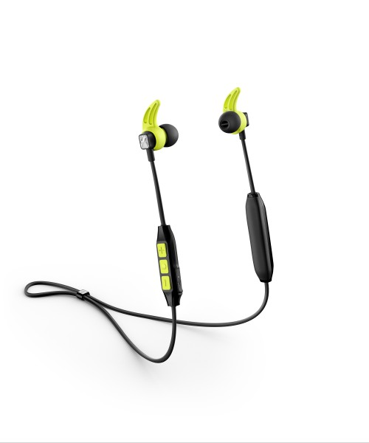Sennheiser’s new CX SPORT in-ear Bluetooth headphones offer the freedom of wireless listening in an ultra-lightweight, splash- and sweat-resistant design.

Thanks to Sennheiser’s exacting quality standards, the CX SPORT is tough enough to take on any challenge with extra assurance provided by splash and sweat resistance. The headphones are equipped with a proprietary speaker system from the audio specialist, delivering clear, detailed sound with an enhanced bass response.

“For many, headphones are a true workout essential. We have designed the CX SPORT to deliver everything athletes need to get the most out of their workout session – great sound, secure fit and a robust but lightweight design”, said Marcel Salzmann, Product Manager at Sennheiser.

**Breadth of features, slimline design**

Despite its slim design, the CX SPORT has a breadth of advanced features to keep pace with everyday life. Multi-connection capability allows the headphones to be connected to up to two devices simultaneously. Meanwhile, Bluetooth 4.2 and Qualcomm® apt-X™ ensure uncompromised wireless Hi-Fi sound. When using the CX SPORT for watching videos, Qualcomm® apt-X™ Low Latency compatibility keeps the audio transmission perfectly in sync with the visuals. Ease of use is ensured by a three-button inline remote control for managing music and calls, as well as by convenient voice prompts that provide notifications of pairing and battery status.

The CX SPORT has a six-hour battery life, which can be fast charged via USB in just ten minutes to offer a further hour of playback, and fully charged in 1.5 hours. The headphones come supplied with a neoprene carry pouch.

The CX SPORT is available now at the [Sennheiser webshop](http://www.sennheiser.com/cxsport-madetomove) and will be available worldwide from June for 129 EUR (MSRP).

**About Sennheiser**

Sennheiser is shaping the future of audio – a vision built on more than 70 years of innovation culture, which is deeply rooted within the company. Founded in 1945, Sennheiser remains family-owned and is today one of the world’s leading manufacturers of headphones, microphones and wireless transmission systems. With 20 sales subsidiaries and long-established trading partners, the company is active in more than 50 countries and operates its own production facilities in Germany, Ireland and the USA. Sennheiser has around 2,800 employees around the world that share a passion for audio. Since 2013, Sennheiser has been managed by Daniel Sennheiser and Dr. Andreas Sennheiser, the third generation of the family to run the company. In 2016, the Sennheiser Group had sales totaling 658.4 million. [www.sennheiser.com](http://www.sennheiser.com)

**Global Press Contact**

Sennheiser electronic GmbH & Co. KG

Jacqueline Gusmag

Public Relations Manager Consumer Electronics

T: +49 (0)5130 600-1540

[jacqueline.gusmag@sennheiser.com](mailto:jacqueline.gusmag@sennheiser.com)